Python Assignment-1

Name- Ajay Singla

RollNo-2210997019

Group-4A(A1)

Q1)– Simple Introductory Python Programs

1.1 WAP to Calculate Area and Perimeter of a Rectangle

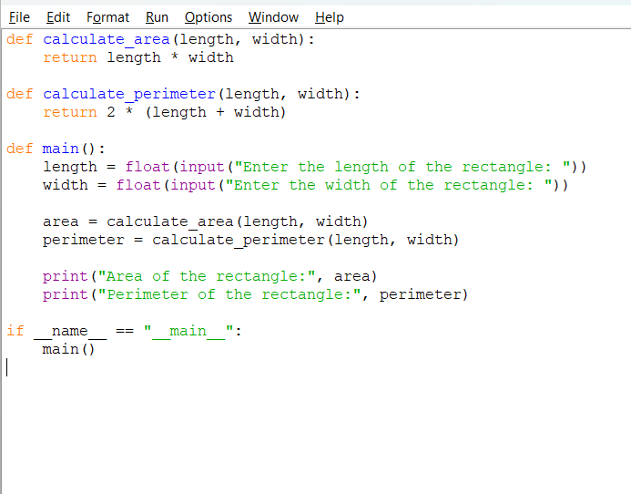

Output------

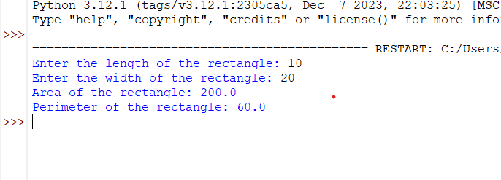

(1.2) WAP to calculate Avg. marks of 3 subjects?

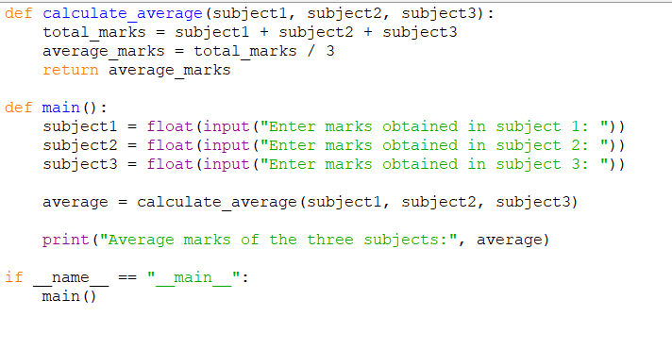

Output---

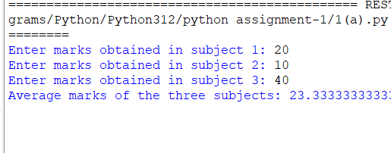

(1.3)WAP to compute compound Interest?

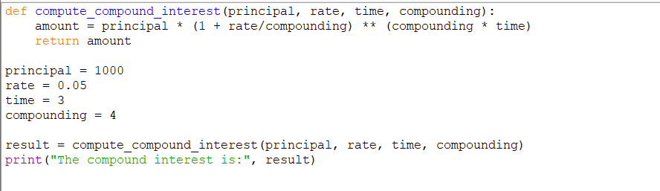

Output---

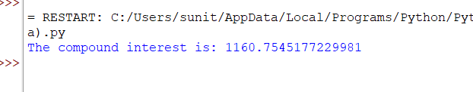

Q2)Working with Strings – basic String Operations

(2.1) WAP to demonstrate Slicing Operations in Strings?

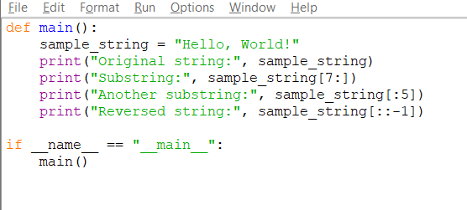

Output---

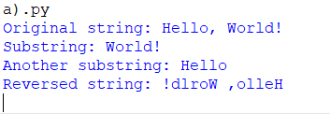

(2.2) WAP to demonstrate built in functions of Strings?

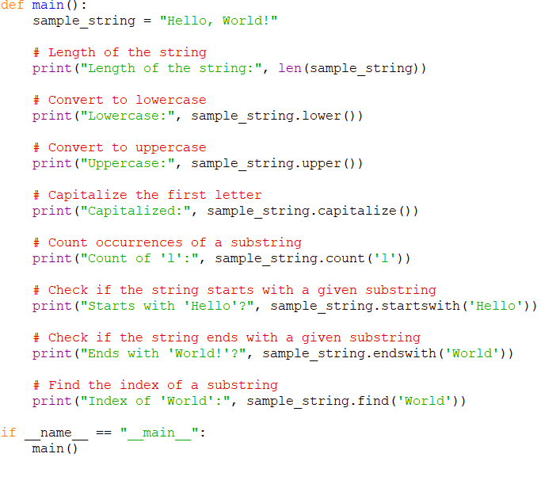

Output--

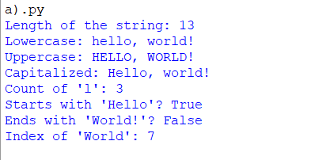

Q3)– Conditionals in Python – Decision Control->

(3.1) WAP to check if one No. is divisible by the other or not?

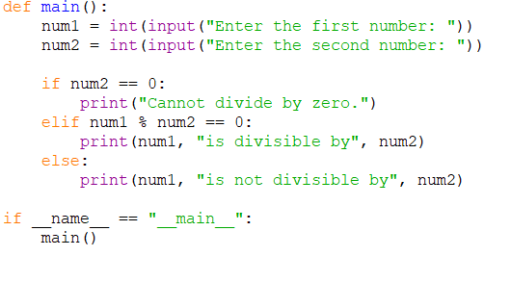

Output---

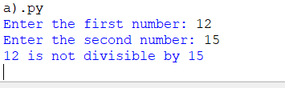

(3.2) WAP to check if a Number is +ve, -ve or zero?

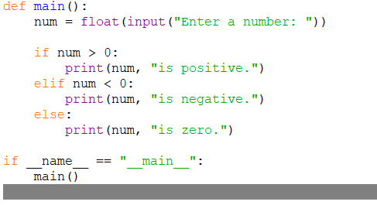

Output--

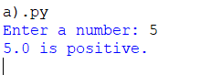

(3.3) WAP to check if a given year is Leap or not?

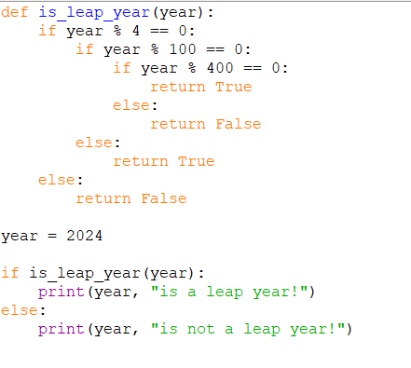

Output--

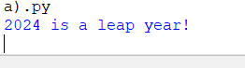

(3.4)WAP to accept basic salary for the employee. Calculate DA as

30% of bs, HRA as 20% of bs if bs&gt;=20000else compute DA as

20% and HRA as 10%. Display the result?

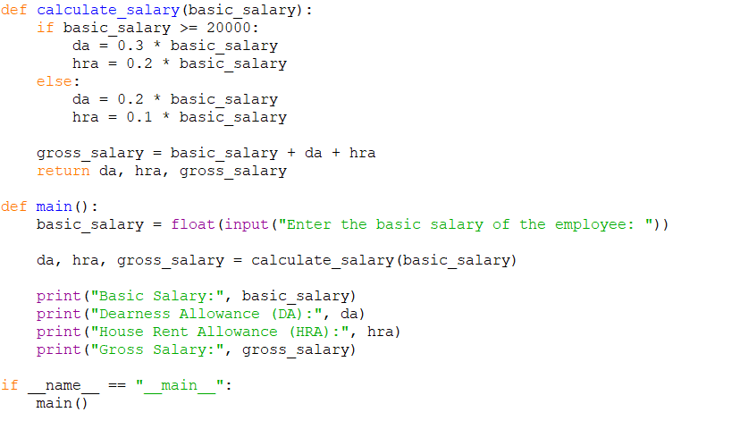

Output---

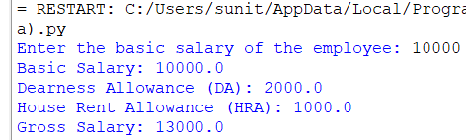

(3.5)WAP to accept sales amount for the salesman. Compute

commission as 20% of sales amount if sales amount&gt;=15000,

comm as 15% if sales amount &gt;=1000 else comm as 10 %.

Display the result?

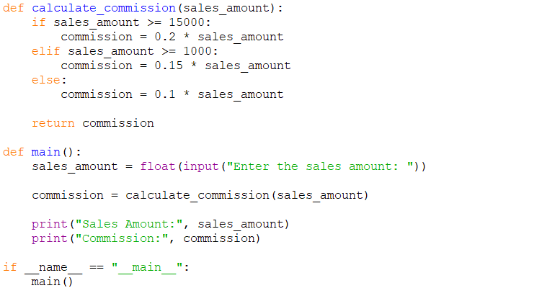

Output---

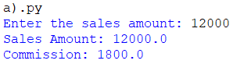

Q4)– While and For loops – Repetition Control Statements

(4.1) WAP to show working of a while Loop with a text?

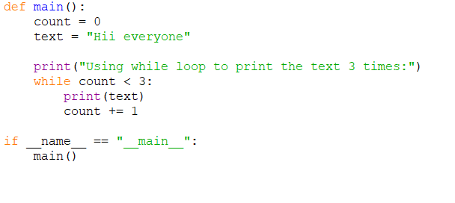

Output---

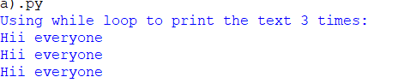

(4.2)WAP to show working of a while Loop with a Numbers?

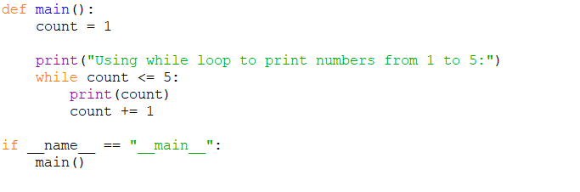

Output---

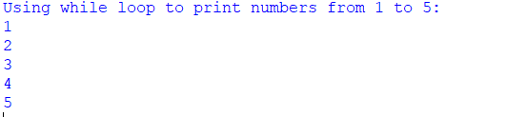

(4.3)WAP to show the working of break and continue statement?

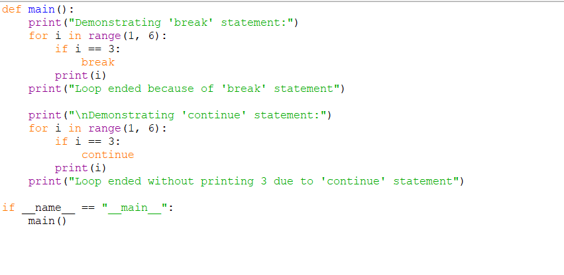

Output---

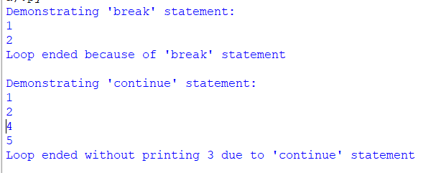

(4.4)WAP to the use of else statement with while and break?

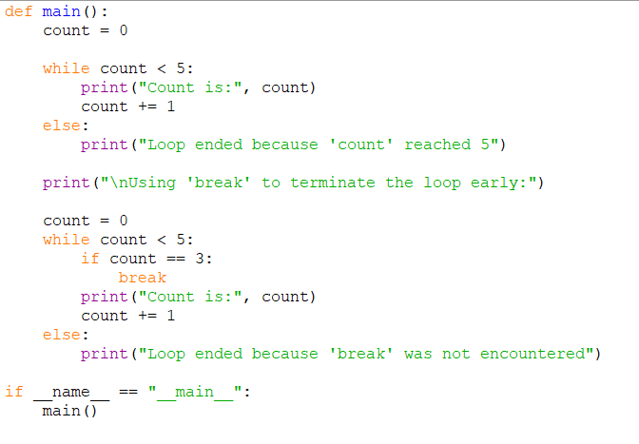

Output---

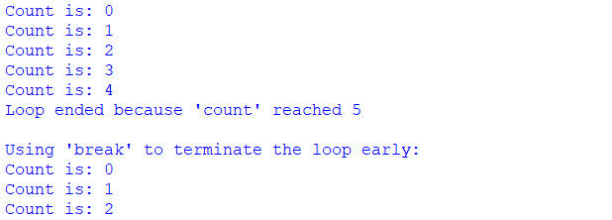

(4.5)WAP to compute the Sum of the Series 4 + 8 + 12 + … + 40?

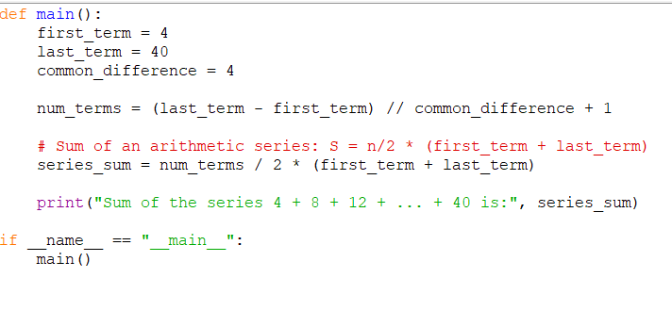

Output---



(4.6)Write a program to display the Fibonacci sequences up to nth term where n is provided by the user?

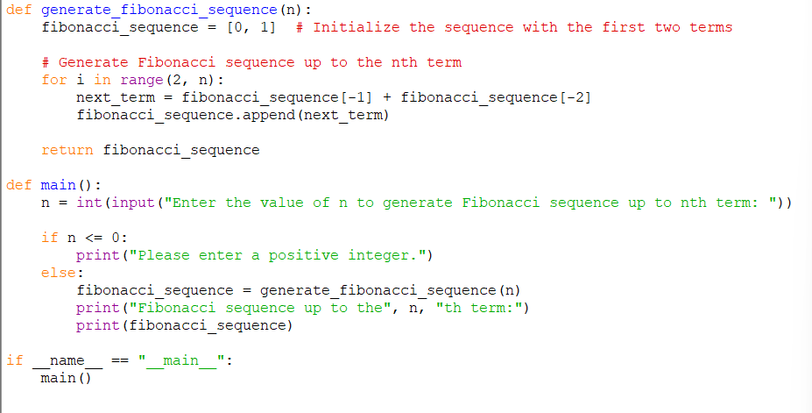

Output---

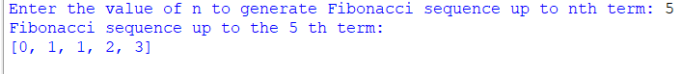

(4.7)WAP that prints multiplication table of a umber using for loop?

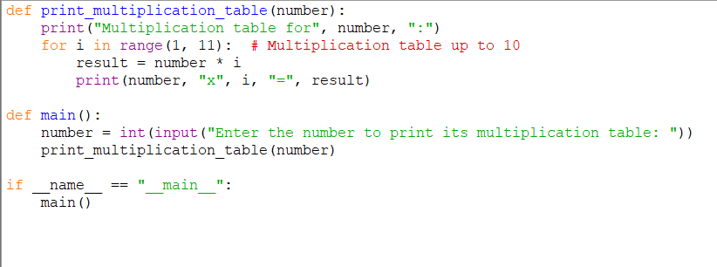

Output----

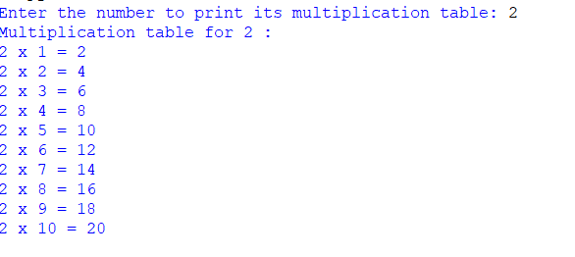

(4.8)WAP To print a Triangle Pattern?

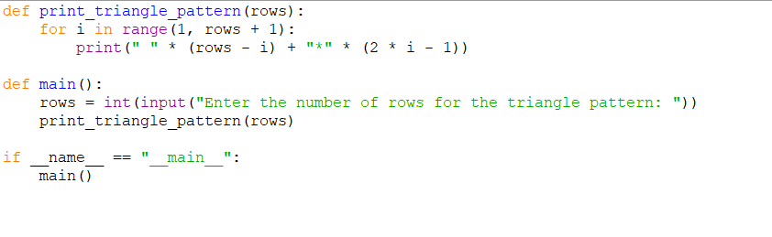

Output---

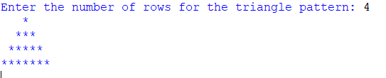

(4.9)WAP to compute Sum of the series 3 + 6 + 9 + … + 30?

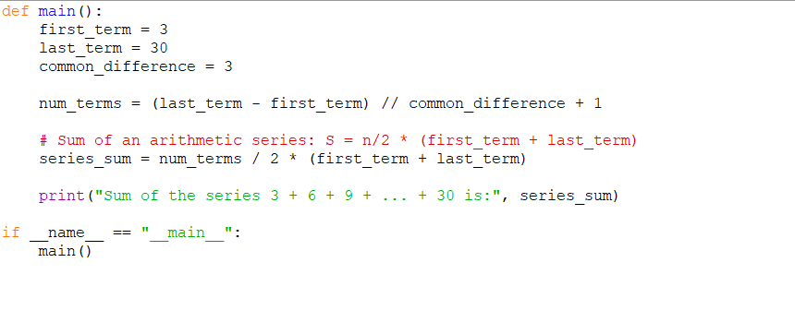

Output---



(4.10)WAP to print the product of the series m = 15 \* 13 \* 11 \* 9 \* 7?

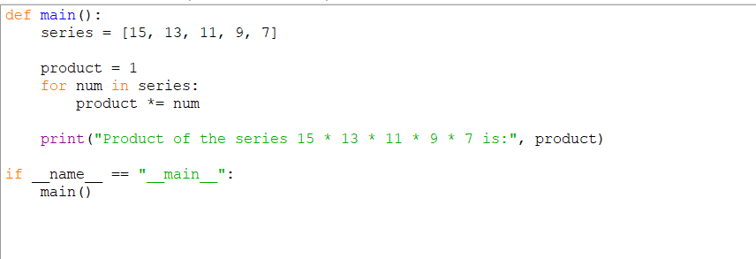

Output---



(4.11)WAP to compute factorial of a Number?

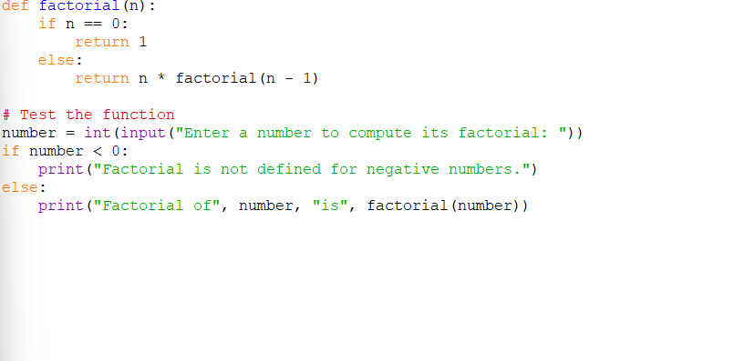

Output---

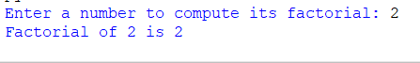

(4.12)WAP to display the Cube of first 10 even numbers?

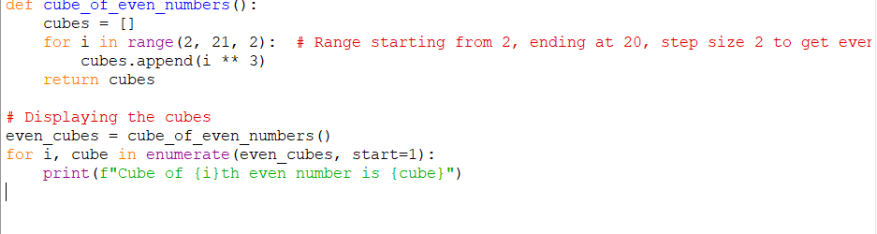

Output---

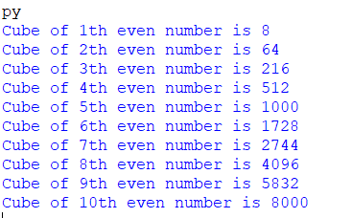

(4.13)WAP to compute sum of first n natural numbers?

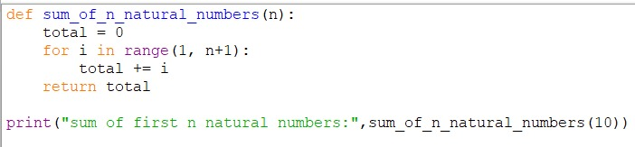

Output---



(4.14)WAP to display 1 to 10 numbers in reverse order?

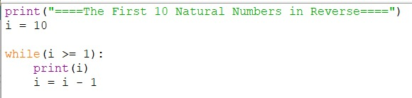

Output---

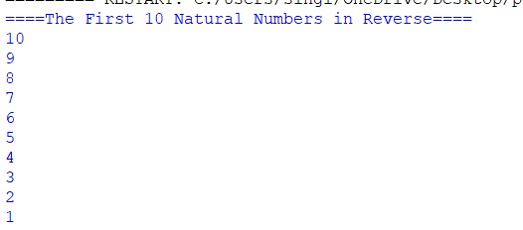

(4.15)WAP to create a list of any specific size. Arrange all the elements in ascending order. Display list before and after sorting

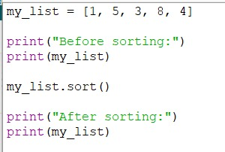

Output---

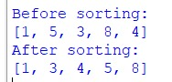

Q5)Working with Lists in Python

(5.1 )WAP to show the creation and working of lists?

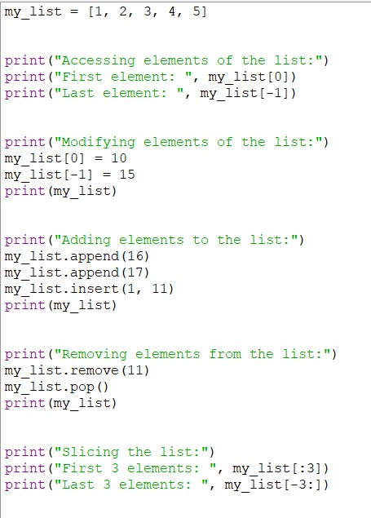

Output---

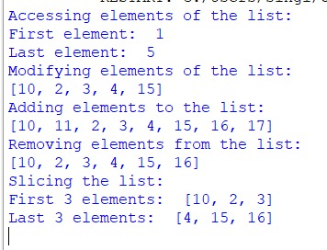

(5.2)WAP to print elements of a list[‘q’,’w’,’e’,’r’,’t’,’y’] in 3eparate lines along with element’s both indexes (Positive and Negative).

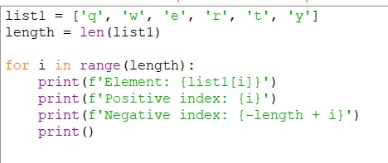

Output---

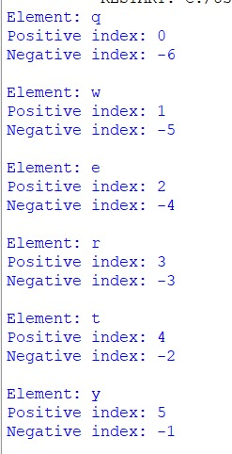

(5.3)WAP to demonstrate the working of methods used with lists?

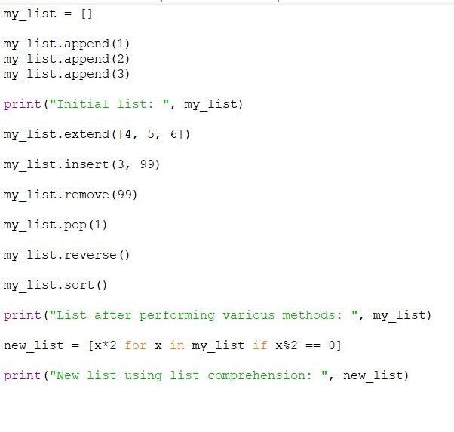

Output---

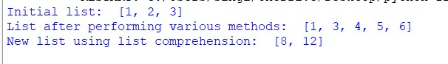

(5.4)WAP to create a 3\*3 Matrix and how to extract individual elements of the

matrix?

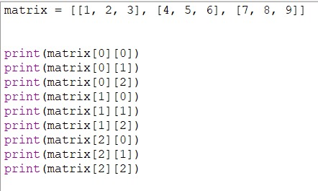

Output---

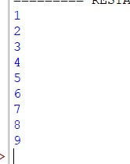

(5.5)WAP to demonstrate built-in functions in Lists?

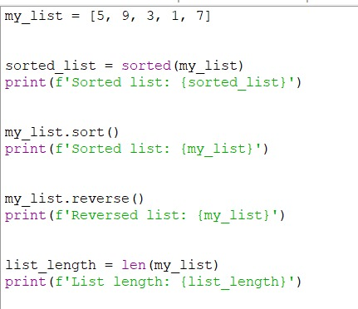

Output---

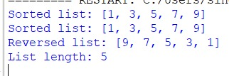

(5.6)WAP to calculate the mean, variance and std. deviation of given list of

numbers

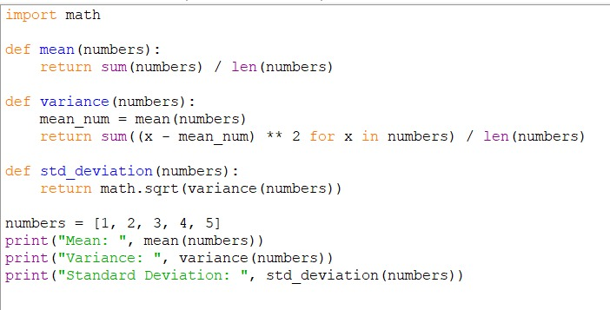

Output---

